ETHICAL HACKING PROJECT (MAJOR)
Major Project Report
Title: Attack, Detect & Secure the Cloud Environment (Red Team & Blue Team Exercise)
Platform Used: AWS Cloud (EC2, Security Groups, VPC)
Attacker Machine: Kali Linux
Defender / SIEM: Linux VM with Wazuh / ELK (as configured)
Student Names: Srishti Anand, Leman Kumar Sahu, Aryan, Subham Gupta, Rahul Kumar Gupta, Roshan Sahu
College: Rungta College of Engineering and Technology, Bhilai.
Course: CSE (Cybersecurity)
Academic Year: 2025–26

1. Introduction
This project demonstrates a real-world cyber-security simulation where students act as both attackers (Red Team) and defenders (Blue Team). The objective is to attack a cloud-based infrastructure deployed on AWS, generate malicious logs, analyze them using a SIEM solution, identify misconfigurations, apply security hardening, and validate improvements by re-attacking the system.

2. Project Architecture
2.1 Cloud Environment (AWS)
- EC2 Instances (VM1, VM2)
- VPC with Public and Private Subnets
- Security Groups and Network ACLs
- SIEM Server (Wazuh / ELK)
- Apache / Nginx Web Server
- FreeIPA (Identity Management)
(Insert Architecture Diagram Screenshot Here)

3. Tools & Technologies Used
3.1 Red Team (Kali Linux)
- Nmap
- Hydra
- Nikto
- Gobuster
- SQLMap (if applicable)
- Default Linux Enumeration Tools
3.2 Blue Team (AWS Linux)
- Wazuh SIEM
- Auditd
- Sysmon for Linux
- Apache Logs
- Auth.log / Syslog
- UFW / IPTables

4. Phase 1 – Red Team Attack Simulation
4.1 SSH Brute Force Attack
Objective: Gain unauthorized SSH access.
Command Used:
hydra -l user -P passwords.txt ssh://<target-ip>
Result:
- Multiple failed login attempts generated
- Logs captured in /var/log/auth.log
(Insert Screenshot – Kali Attack + AWS Logs)

4.2 Port & Service Enumeration
Tool: Nmap
nmap -sV -A <target-ip>
Findings:
- Open SSH (22)
- Open HTTP (80)
- Unnecessary ports exposed
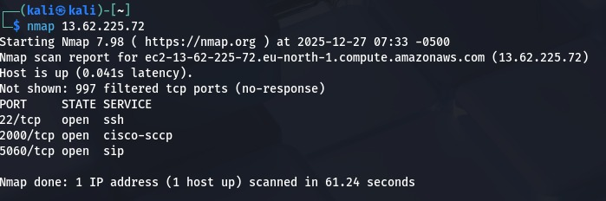
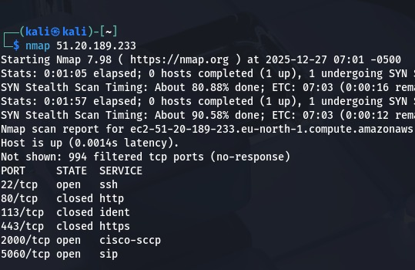

4.3 Web Application Attacks
a) Directory Enumeration
gobuster dir -u http://<target-ip> -w /usr/share/wordlists/dirb/common.txt
b) Vulnerability Scanning
nikto -h http://<target-ip>
Findings:
- Directory traversal risk
- Missing security headers
(Insert Screenshots)

4.4 Privilege Escalation Attempts
- Checked SUID binaries
- Misconfigured sudo permissions
find / -perm -4000 2>/dev/null
(Insert Screenshot)

5. Phase 2 – Blue Team Investigation
5.1 SIEM Log Analysis
Logs Analyzed:
- /var/log/auth.log
- /var/log/syslog
- Apache access & error logs
- Wazuh Alerts Dashboard
Indicators of Compromise (IOCs):
- Attacker IP addresses
- Repeated failed SSH attempts
- Suspicious URL requests
(Insert SIEM Dashboard Screenshots)

5.2 Identified Misconfigurations
- Weak SSH authentication
- Open ports to public network
- No rate limiting
- Default web server configuration
- Weak password policies

6. Phase 3 – Security Hardening
6.1 SSH Hardening
PermitRootLogin no
PasswordAuthentication no
- Enabled key-based authentication
- Changed SSH port
- Applied rate limiting
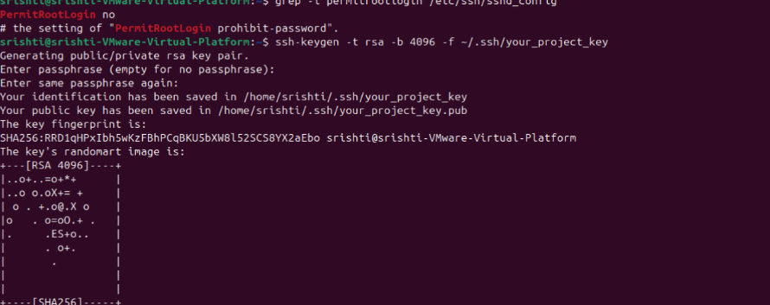

6.2 Firewall Configuration (UFW / IPTables)
ufw allow <SIEM-IP>
ufw deny 22
- SSH allowed only from SIEM VM
- Restricted DMZ to Internal Network

6.3 Logging Enhancements
- Installed Sysmon for Linux
- Custom Auditd rules
- Enabled verbose Apache logging
(Insert Configuration Screenshots)

6.4 Server & Application Hardening
- Disabled unused services
- Enforced strong password policies
- Least privilege permissions
- Secured FreeIPA
- Hardened Apache/Nginx

7. Phase 4 – Re-Attack After Hardening
The same attacks were repeated from Kali Linux.
Observations:
- SSH brute force blocked
- Reduced open ports
- Clear SIEM alerts with faster detection
- Improved security posture
(Insert Before/After Log Comparison Screenshots)

8. Final Security Posture Report
Parameter | Before Hardening | After Hardening
Open Ports | Multiple | Minimal
SSH Security | Weak | Strong
Logging | Basic | Advanced
Detection | Delayed | Real-time

9. Conclusion
This project provided hands-on experience in offensive and defensive security. By attacking, detecting, and hardening a real AWS environment, we gained practical SOC-level skills and an understanding of real-world cyber defense mechanisms.

10. Screenshots Section
(All screenshots must clearly show student name and AWS account as per instructions.)

11. References
- Kali Linux Documentation
- AWS Security Best Practices
- Wazuh Documentation
- OWASP Top 10

